A Definitive Guide to Generative AI with Amazon Bedrock

Chapter 6: Overview of Retrieval-Augmented Generation (RAG)

In the rapidly changing world of generative AI today, it is very important to be able to come up with answers that are accurate and relevant to the situation. But as these models have become more complicated, a major flaw has shown itself: they can't use outside information sources to make their results better and more factual.

In this case, retrieval-augmented generation (RAG) is very important. The RAG method is very effective because it combines the best parts of large language models with the power of information retrieval systems to find knowledge. By blending these two parts together smoothly, RAG models can dynamically access important external information during the generation process. So, the generated outcomes are clear and logical. They are based on facts, which makes them reliable.

In this part, you will learn about RAG's main ideas and build patterns. You will also learn how it can be used in real life and the problems that come up when you try to do it. First, you will look at the retrieval models that RAG is based on and talk about why this method is so useful for many different natural language processing tasks.

After that, you'll look more closely at the RAG design, checking out the part that embeddings play and how language models and knowledge retrieval systems can work together. You will also learn about LangChain, a powerful system that makes it easier to build RAG-based apps. You will also get an idea about llama LlamaIndex with use cases.

As an example of how RAG can be used in real life, you will build a simple solution to show how this technology can be used to make smart, knowledge-driven user experiences. Lastly, you'll look at some advanced RAG design patterns and understand the most important things to keep in mind when working with this approach.

You will fully grasp retrieval-augmented generation, its basic ideas, and the useful tools and methods you can use to include this strong method in your own natural language processing tasks by the end of this chapter.

6.1 Introduction to RAG

Imagine a fictitious insurance company, AnySecureLife, had trouble providing personalized insurance plans because agents didn't have enough capability to navigate customer detail information from enterprise. Emma, a possible buyer, came up to them one day looking for health insurance. AnySecureLife had created a way to write policies leveraging the large language model (LLM), but it didn't have up-to-date information on Emma's health history or financial situation. This limitation resulted in generic and often inaccurate suggestions.   
To address this issue, AnySecureLife’s product team devised a strategy to integrate real-time retrieval from health databases and financial records. By doing so, they generated a customized and accurate policy for Emma. By taking this new method, they were able to change what they were selling and make sure that every customer got well-informed, custom insurance solutions. This is just one example. This approach could be a design pattern that is used in many different industries’ use cases.   
RAG enhances the results of a large language model by using an external, proprietary knowledge base in addition to its original training data to come up with more accurate and well-thought-out answers. Large language models (LLMs) are trained on vast amounts of data and use billions of factors to come up with new answers to questions, translate languages, and finish sentences.  
RAG uses the power of LLM and adds the organization's own information base to make the context better. That too without having to train the model again. This is a cost-effective way to make sure that LLM output stays current, correct, and useful in different situations.   
In 2020, Patrick Lewis and his co-authors came up with the idea of retrieval-augmented generation (RAG). It has been used as a design pattern in a huge number of other study papers and business services since then (refer: https://arxiv.org/pdf/2005.11401). The RAG project is a big step forward in generative AI, even though the name was made by accident. A lot of language models are more accurate and effective when they use real-world sources.   
RAG addresses a fundamental limitation of large language models (LLMs). Traditional LLMs, built on neural networks with billions of parameters, excel at generating text based on generalized patterns in human language. However, they often fall short when tasked with providing detailed, up-to-date information on specific topics.   
RAG connects LLMs with more resources that have the most up-to-date technical knowledge to deal with this problem. This **general-purpose fine-tuning** recipe, which was made with help from researchers at Facebook AI Research, University College London, and New York University, lets any LLM connect to various outside knowledge bases. This method makes it much easier for the model to come up with correct and useful answers. It is a major step forward in the development of generative AI.

# 6.2 Understanding Retrieval Models

You will learn about the retrieval models in this section. It is very important for making better information retrieval systems because it gets useful data from a lot of different sources to help programs like search engines and virtual assistants. Retrieval models help find and get relevant information quickly for your queries.

AnyTripGenius, a fictional app, is an online travel company for planning a trip. AnyTripGenius uses a retrieval model to look through huge databases of travel guides, reviews, and user-generated content to find suggestions for holiday spots. If you search for "family-friendly vacation spots in Singapore" in AnyTripGenius app the model looks through its database for relevant documents.

The retrieved outcomes provide personalized and accurate suggestions. For instance, suggest the Singapore Zoo or Universal Studios Singapore based on what you like and what the latest travel trends are. The retrieval model quickly filters large data sets. This ensures you receive current and useful information.

To understand retrieval models, you need to know how these systems leverage algorithms to rank and retrieve information based on factors like relevance, recency, and your intent. Retrieval models significantly improve the accuracy and relevance of the information provided by combining sophisticated search techniques with a comprehensive knowledge base. It makes them significant generative AI design patterns.

6.3 Why Retrieval-Augmented Generation

An LLM is like an overenthusiastic friend who answers everything confidently. However, it ignores current events. Such behaviour can negatively impact trust, which is undesirable for the customer or user who wants to use that information.   
RAG addresses these challenges by redirecting LLMs to retrieve relevant information from proprietary, predetermined knowledge sources. This approach allows organizations to have greater confidence in the context-aware generated output. It aids in understanding the prompt flow lifecycle and how LLM generates responses.  
**Affordable Implementation**: Solution development powered by generative AI usually starts with foundation models (FMs). These LLMs, accessible through APIs, acquired their knowledge from vast quantities of generalized data. Retraining these models for organizational or domain-specific information is expensive. RAG is a cost-effective method because it adds new data to the LLM without requiring training all over again. This makes the RAG approach more adaptable.   
**Access to Up-to-Date Information**: It's challenging to keep static training data relevant. RAG enables you to directly link generative models to frequently updated sources of information, such as live social media feeds, news sites, and enterprise data. So, you can provide enhanced context to the generative AI models with the latest research, current data, or news. This ensures that the LLM can provide you with the most current information.   
**Reduced hallucinations**: According to research, RAG design patterns tend to produce fewer hallucinations and more accurate responses. This pattern is also less prone to leaking sensitive information. This makes them a more reliable choice for content creation.   
Increased User Trust: RAG allows you to present generated output with source attribution, increasing business trust. You can include citations or references to sources along with the generated output. This transparency enhances trust and confidence in the generated content.  
**Flexible Developer Control**: RAG simplifies testing and enhancing its generative AI solution. You can easily modify information sources to meet changing needs and various use cases. You can troubleshoot issues when the LLM cites inaccurate information sources. Access to sensitive information is restricted by authorization levels. This also guarantees appropriate responses.   
**Better LLM Memory**: Traditional LLMs use parametric memory. RAG addresses the limited memory capacity of traditional LLMs. It enhances the LLMs' knowledge base for better responses by introducing non-parametric memory with external knowledge sources.   
Enhanced Context Awareness: RAG enhances the contextual comprehension of LLMs by retrieving relevant documents. This yields generated outcomes that align with the prompt's context, producing more precise outcomes.  
**Updatable Memory**: You can refresh the external knowledge base, ensuring LLM replies are current. RAG enables real-time adaptation to sources without needing extensive model retraining.  
Citations for sources: RAG design patterns increase trust by showing the source of answers. You can see the data used by the LLM, which builds trust in the responses.  
These benefits make RAG a transformative framework in natural language processing, addressing traditional language model limitations and enhancing AI application potential.

# 6.4 RAG Architecture

You will gain a detailed understanding of the RAG architecture in the following sections (Figure 6.1).

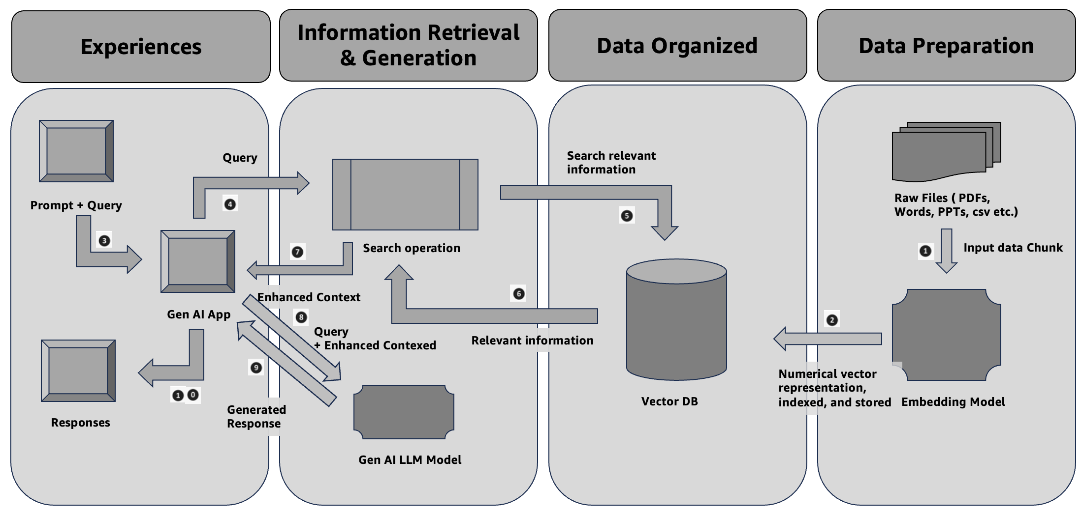

Figure 6.1 RAG architecture block diagram

# **Data preparation and organization**

# 1. Documents must be chunked into appropriate lengths based on the selected embedding model. The text embedding component converts the input text, whether it's a document or other textual data, into a numerical vector representation. An embedded LLM is required to perform this task. This is a continuation process for additional documents or updating the existing documents. This process continues for additional documents or updates to existing ones.

# 2. This vector maintains the meaning and language connections between words or phrases, known as chunk vectors. This allows the system to grasp the meaning and context of the input. It does not simply treat this as a sequence of characters.

# The vector database (Vector DB) component allows for efficient retrieval and processing of relevant information. The Vector DB stores the vector representations (embeddings) of text chunks or documents generated by the text embedding component. It produces document embeddings and populates a vector search index with this data. **Experiences and Information Retrieval and Generation** 3. The prompt, along with the query, is passed to the generative AI-powered application.

# 4. The query initiates a search operation. The query converted into an embedded vector. 5. The query vector searches a vector database. This database has precomputed vectors. This represents potential contexts for the model to generate an outcome. 6. The system retrieves the most relevant contexts based by comparing the similarity of their vectors to the query vector. 7. The search operation provides improved context to the application powered by generative AI. 8. The application sends the prompt, query, and enhanced context to the generative AI model to generate a response.  9. The generative AI-powered application receives the generated responses. 10. you can then interact with and experience the responses.

# 6.5 Overview of Embeddings

In the context of RAG, embeddings play an important role in connecting large language models (LLMs) with external knowledge sources. So, embeddings help bridge the gap between the retrieval and generation phases.

**Embeddings** are numerical representations of text (or other data types) that capture the meaning or semantic relationships between words, phrases, or documents. These are typically represented as high-dimensional vectors, where similar texts are placed closer together in the vector space. The goal of embeddings is to transform unstructured data into a format that can be efficiently processed by machine learning models.

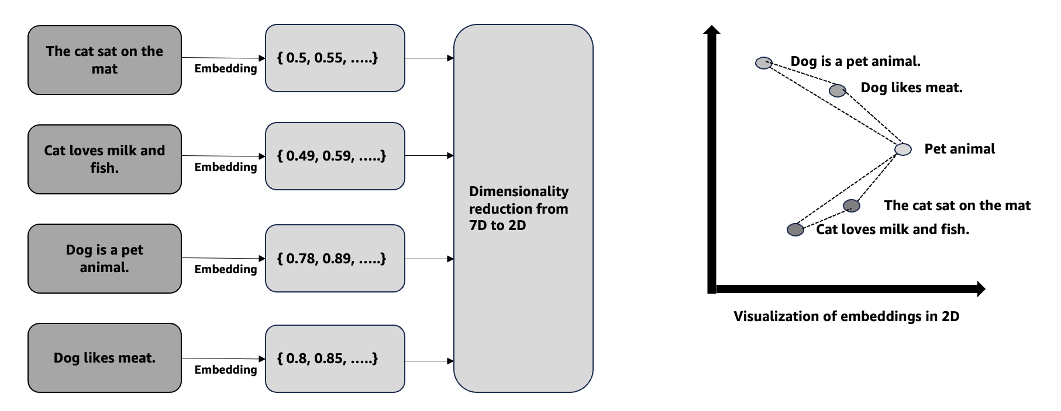

Figure 6.2 Embeddings vector from sentences (This is for illustration purpose)

There are a variety of objects that need to be embedded for different use cases. You will mostly learn documents embedded throughout this book. You will learn image embedding in Chapter 19 of this book.

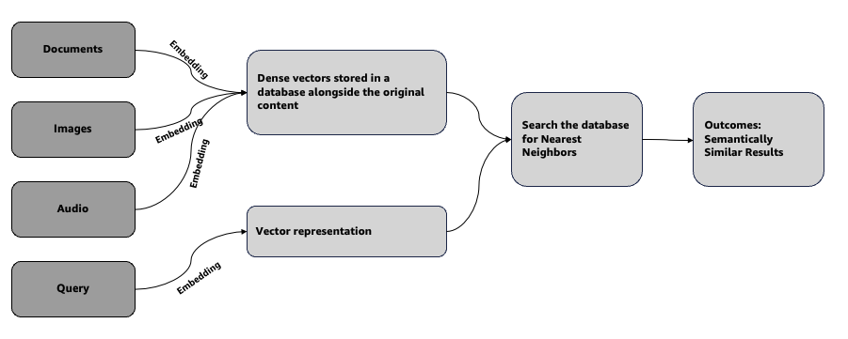

Figure 6.3 Flowchart of how embeddings work

Let you first explore the role of embeddings in RAG. These are four important steps.

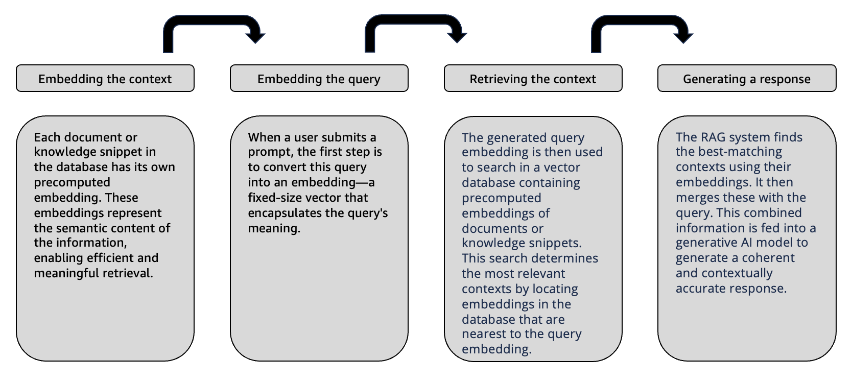

Figure 6.4 Role of embeddings in RAG

#### Let you understand the above concept with an example. Imagine you are an insurer agent of an insurance company. You ask a query “What is the best insurance products of my company?”

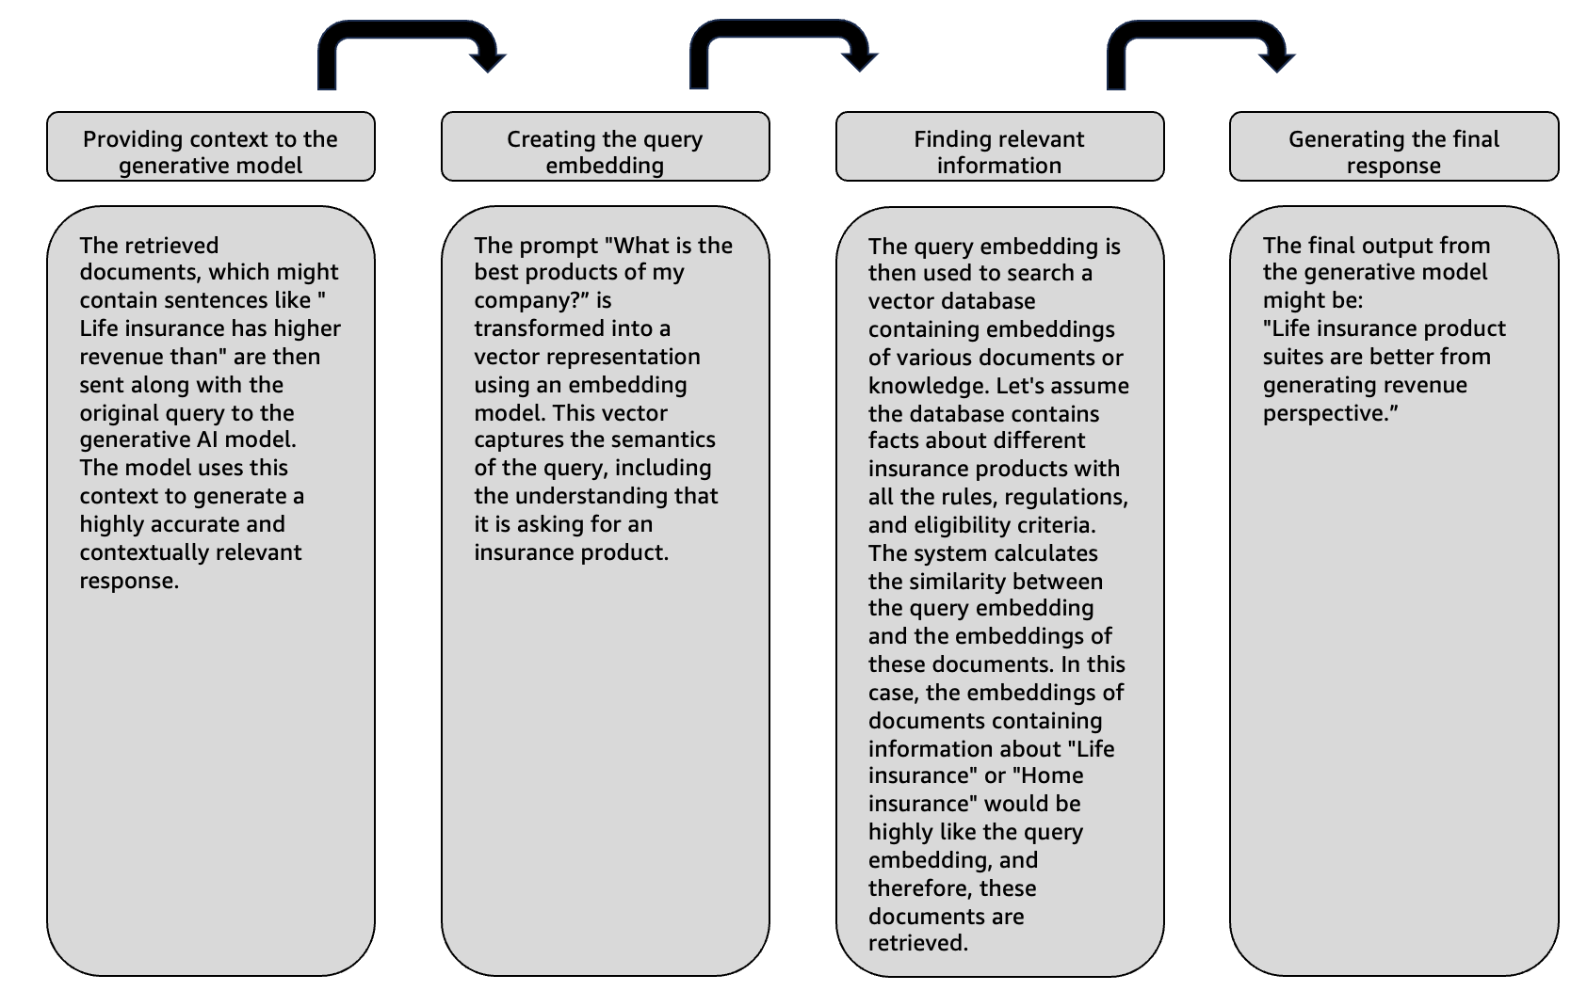

Figure 6.5 Role of embeddings in RAG – an example

RAG enhances response accuracy and relevance by using embeddings to find and retrieve the most pertinent information. This is particularly effective for complex or specialized queries.  
  
**Efficient searching**: Embeddings allow the system to search for information based on meaning rather than keywords, making retrieval more efficient and accurate.  
**Ensuring contextual relevance**: By retrieving semantically related documents, embeddings guarantee that the generative model has the appropriate context to provide more significant and coherent replies.  
**Scalability**: Embedding-based search scales well with large datasets, making RAG suitable for complex, multi-domain applications.  
  
In summary, embeddings serve as the foundation of the retrieval process in RAG by converting text into a format that machines can understand. It allows for the integration of external knowledge into the generative AI workflow.  
  
Vector embeddings offer significant advantages, but they also present several challenges and limitations.  
  
**Quality of training data**: The effectiveness of embeddings is significantly influenced by the quality of the training data. Skewed or inaccurate embeddings can result from biased or incomplete data.  
Managing high-dimensional space: Working with high-dimensional vector spaces can be computationally demanding, requiring substantial resources and time, especially with large datasets.  
Avoiding information loss: While embeddings simplify data into a more manageable format, this process can occasionally remove subtle details, resulting in the underrepresentation of significant nuances.  
**Addressing interpretability challenges:** Embeddings may be challenging to comprehend, especially for those without knowledge in machine learning.  
**Balancing generalization with specificity**: Finding the right balance between creating embeddings that are both broadly applicable and specifically useful for targeted tasks can be challenging.  
  
To effectively implement vector embeddings, it is essential to understand these challenges, which allows for informed decisions and the anticipation of potential obstacles.

# 6.6 Overview of LangChain

LangChain serves is an open-source framework that assists developers in creating applications that utilize large language models (LLMs). (Refer: https://python.langchain.com/v0.2/docs/introduction/) LangChain offers a suite of tools and abstractions that enhance the customization, accuracy, and relevance of the information produced by these models. You can utilize LangChain to develop new prompt chains or adjust existing templates to meet your requirements more effectively. Furthermore, LangChain offers components that enable LLMs to access up-to-date data without retraining, ensuring that the models remain relevant and efficient with RAG design patterns.

For example, suppose you are developing a customer service chatbot. With LangChain, you can easily customize the prompts for the LLM to align with the brand's specific tone and style, while also incorporating new data sources to guarantee that the chatbot delivers current and accurate information.

LangChain plays a vital role by connecting large language models (LLMs) with the unique requirements of organizations. Although LLMs excel at addressing general inquiries, they frequently encounter difficulties with specialized questions outside their training. For instance, an LLM may offer a general estimate of health insurance costs, but it cannot deliver the precise price of a specific health insurance product that your company offers.

To achieve this level of specificity, you typically integrate the LLM with the organization's internal data and carefully design prompts through prompt engineering with RAG design patterns.

LangChain simplifies the process of creating these data-responsive applications, making prompt engineering more efficient. It helps rapid development of generative AI powered applications.

**Adapting Language Models for Specific Needs**: LangChain enables organizations to create task-specific LLM applications, such as conversational summaries and RAG workflows, by utilizing internal data without the need for retraining or fine-tuning models.

**Making AI Development Easier**: LangChain makes it easier to combine data sources and make prompts better. That way, you can make complex apps faster by changing the models and tools that LangChain already provides instead of starting from scratch.

**Strong Community of Developers**: LangChain is an open-source tool with a strong community that helps it run. You can get help from the community and use tools that connect LLMs to external data sources.

There are three main properties of LangChain, though you will learn most of the below components throughout this book with some examples.

**Components**: The creation of apps is made much simpler with the usage of them, which are similar to building blocks. Just for a moment, you are developing a chatbot. When you use LangChain, you won't have to begin from the very beginning. You may make use of pre-made components such as LLM wrappers, which are helpful in maintaining language models, prompt templates, which standardize the way in which you ask questions, and indexes, which are helpful in accessing important information in a timely manner. These parts are modular, which means that you may combine and combine them in any way that best suits your requirements.

**Chains**: Chains allow you to link multiple components together to achieve a specific goal. Continuing with the chatbot example, suppose you want the bot to understand a question, search for the right information, and then provide an answer. These steps can be linked together to make the process easier to manage, debug, and maintain.

**Agents**: Agents enable your application to interact with the outside world. For instance, if your chatbot needs to fetch real-time weather data, an agent can connect to an external API to get that information. As a result, the chatbot becomes more intelligent and able to do more than just respond to preset queries.

**Memory**: LangChain allows developers to incorporate memory into their applications, so the AI can recall and use information from past interactions. This might vary from basic systems that retain current dialogues to more intricate frameworks that evaluate historical communications to provide the most relevant answers. In a customer service chatbot, memory may be used to retain a user's prior difficulties, enabling the bot to provide more tailored assistance in subsequent contacts.

You will explore much of this concept in Section 6.9.

# 6.7 Overview of LlamaIndex

LlamaIndex, previously called GPT Index, is a robust open-source library designed to improve the capabilities of large language models (LLMs) in document retrieval and indexing. It offers a strong framework for organizing, retrieving, and synthesizing information, which greatly enhances the functionality of LLMs. This makes them more proficient in managing complex, document-heavy applications like knowledge management, question-answering, and content summarization. LlamaIndex proves especially valuable in Retrieval-Augmented Generation (RAG) workflows, where effective retrieval and indexing.   
LlamaIndex provides advanced document management through hierarchical chunking, multi-stage retrieval, customizable parsers, and vector store integration, enhancing retrieval accuracy and contextual relevance for large documents. LlamaIndex facilitates the division and indexing of documents in structured forms, hence improving response quality via layered refining. It seamlessly integrates with RAG processes and accommodates vector databases like OpenSearch and Pinecone, facilitating efficient retrieval across many areas. The AutoMergingRetriever also combines answers that make sense from different parts of a document. This makes it perfect for complicated, information-heavy tasks where accuracy and context are very important. You will learn each functionality at Section 6.9 with some examples.  
Let's first examine the advantages of the LlamaIndex approach.  
  
**Enhanced Contextual Understanding**: LlamaIndex indexes documents hierarchically and retrieves information at a chunk level, enabling LLMs to provide responses that are rich in context and highly relevant. This functionality offers significant benefits for use cases that need a thorough domain understanding, such as legal, medical, or technical documents.  
**Efficient Scalability for Large Datasets**: LlamaIndex efficiently manages extensive document repositories through its hierarchical structure and optimized retrieval pipelines. Organizations that need to manage and query large datasets while ensuring quick response times and accuracy find this scalability essential.  
**Flexible and Modular Design**: The modularity of LlamaIndex allows for easy adaptation to various use cases. Developers can customize the index creation, retrieval methods, and chunking processes to meet the specific requirements of each project, facilitating a flexible development process that addresses diverse organizational needs.  
**Improved Retrieval Accuracy in RAG Workflows**: LlamaIndex enhances the ability of LLMs to retrieve relevant information in RAG scenarios, ensuring that the results are more accurate and contextually appropriate. This improvement significantly helps applications that need accuracy in practical settings.  
**Open-Source Accessibility and Community Support**: LlamaIndex is an open-source library. It thrives because the community continuously contributes and supports it. Contributors enhance the library. They add new features and modify existing ones. They also share improvements. This fosters innovation and collaboration. Together, they improve document retrieval efficiency.  
  
Let's explore the comparison between the LangChain and LlamaIndex frameworks using the tables provided below.

|  |  |  |
| --- | --- | --- |
| Key aspects | LangChain | LlamaIndex |
| Core Functionality | Workflow orchestration, chaining, and tool integration | Document indexing, parsing, and retrieval |
| Primary Use Cases | Chatbots, automation, task-based agents | Knowledge bases, document Q&A, RAG workflows |
| Document Management | Tool- and API-based document access | Hierarchical chunking and context retention |
| Modularity | Chains, agents, toolkits | Node parsers, retrieval pipelines, vector store support |
| Integration | APIs, tools, multiple LLMs | Vector stores, RAG pipelines |

Table 6.1 Comparison between LangChain and LlamaIndex

# 6.8 Overview of a Simple Streamlit Application

Streamlit is a powerful and easy-to-use framework for creating interactive web applications with Python. It allows you to turn your data scripts into shareable web apps quickly without needing any web development proficient skills. You will learn to create some basic Streamlit Application in the rest of the book. [(](https://streamlit.io/) Refer: <https://streamlit.io/> ) You already learned a basic Streamlit Application at Chapter 3.

# 6.9 A Sample Application Building with RAG

# 6.10 Challenges & Considerations

# Implementing retrieval-augmented generation (RAG) involves several challenges. It is important to address these challenges for successful deployment. The aim is to develop a RAG system that fulfills technical requirements. Additionally, the system should adapt to changing needs. It must also ensure trustworthiness. Choosing the right chunk size and strategy: This is important in RAG. The chunk size affects the retrieval model's performance and the accuracy of generated content. If a chunk is too large, it may contain irrelevant data, reducing the value of the information retrieved. On the other hand, if a chunk is too small, it may lack context, resulting in incomplete or unclear responses. For instance, a legal firm using AWS Bedrock for contract analysis might face issues. Small chunks could cause the retrieval model to miss important context, like the relationship between chunks. Large chunks may contain irrelevant sections. This includes boilerplate text. Such content can confuse the generation model. Building a strong and scalable pipeline: This is also important for RAG implementation. It should efficiently handle data ingestion, processing, retrieval, and generation. AWS Bedrock provides strong tools for integration. Careful planning is needed for data flow, parallel processing, and failure management. A global e-commerce platform requires a solid RAG pipeline for real-time product recommendations. This pipeline must handle large data volumes and quickly access relevant product information. It must handle occasional retrieval failures. Ensuring retrieved data is contextual and trustworthy: A significant challenge in RAG systems is ensuring that the retrieved data is presented in the right context, maintaining the interpretability and trustworthiness of the generated output. Without the correct context, the you might question the validity of the information. For instance, if you take the retrieved medical records out of context in a healthcare setting, using RAG to assist in diagnosing conditions could lead to dangerous misinterpretations. For instance, a symptom mentioned in a different context could be mistakenly attributed to the wrong condition for a petient. Task-based retrieval: This needs customization for each specific task or query. This can be difficult in changing environments. AWS Bedrock's adaptability to different tasks requires careful tuning. In this way, the retrieval process is tuned to meet the needs of the task. Different questions are answered by an automatic customer service system. Technical assistance and account management both use different ways to get information. To find these positions, you need to optimize the RAG system. This improvement ensures that the generate outcome you get is relevant and useful. Optimizing the vector database for accurate document retrieval: Optimizing the vector database is essential for accurate document retrieval. The efficiency of a RAG system relies on this optimization. It indexes and retrieves relevant chunks of data. Proper tuning is crucial for search accuracy and performance. This is especially important with large data sets. For example, a financial institution retrieving regulatory documents from AWS Bedrock must fine-tune the vector database. They need to prioritize the most recent and relevant regulations. Any oversight could lead to outdated or irrelevant compliance information. Avoiding retrieval of outdated content: Retrieving outdated content is a major challenge in fast-evolving fields. It can mislead users. The RAG system should focus on the latest data. It must filter out old information. For instance, a tech firm using RAG for software documentation may encounter problems if outdated API references are retrieved. This can mislead you. Regular updates are essential. A strategy for managing outdated content is also necessary. This ensures the information remains accurate and relevant. Optimizing response times for users: User experience in a RAG system heavily relies on response time. Slow retrieval or generation processes can frustrate you and hinder adoption. Optimizing the entire pipeline for speed while maintaining accuracy is a delicate balance. For example, in a live chatbot system, you expect near-instant responses. You may abandon the interaction before receiving the necessary information if AWS Bedrock's RAG model does not optimize for response time, thereby negatively impacting the overall user experience. Managing inference costs: Managing inference costs is important when running RAG design pattern. Models can be costly, especially when there are a lot of queries of large datasets. Accuracy and cost must be balanced. For example, a large media company might use RAG to personalize content for millions of users. You must manage inference costs on AWS Bedrock carefully. This strategy will guarantee effective solution and assist avoid unsustainable costs. Maintaining data security: Data security is vital for sensitive information in RAG systems. AWS Bedrock offers robust security features. Still, you need extra measures like encryption, access control, and regular audits. For instance, a government agency should manage access and encrypt data when accessing classified information. A breach can cause significant legal and operational problems. Supporting continuous learning and adaptation: Supporting continuous learning and adaptation is essential for generative AI systems. They must learn and adapt to new data and changing user needs. You need to update the model and retrain it with new data. Fine-tuning retrieval methods is also important. RAG design helps avoid any impact during customization of the model. For example, a news organization using RAG must update the system with the latest news regularly. AWS Bedrock supports this by enabling continuous model customization, ensuring the content remains relevant and accurate.

# 6.11 Advanced RAG Design Patterns

This section presents various RAG design patterns. These patterns are designed for different use cases. You will examine them at a high level. Each pattern has its own use cases, benefits, and limitations.

**Simple RAG pattern**: Simple RAG pattern is sometimes called Naive RAG. This pattern represents the most straightforward approach to retrieval-augmented generation. You are already familiar with this RAG pattern from all the previous sections (Figure 6.1). In this setup, a retrieval system receives a user query and retrieves relevant documents from a database. The retrieval system then passes these documents to a large language model (LLM) to generate a response.

You will learn the benefits of this RAG pattern below.

Simplicity: The naive RAG pattern is simple to implement and serves as a useful starting point for building more complex systems.

Baseline for comparison: It provides a clear benchmark against which more advanced RAG techniques can be measured.

Cost-Effective: With fewer components and a simpler architecture, this approach is generally more cost-effective and resource-efficient.

Some of the potential limitations of this RAG pattern are explained below.

**Limited accuracy**: The system may pull in less relevant or outdated information due to an unoptimized retrieval process, which could affect the quality of the generated response.

**Lack of context**: The naive approach doesn't incorporate additional context or user preferences, which can lead to more generic and less personalized outputs.

**Scalability issues**: As the volume of data grows, the naive RAG pattern may struggle with efficiency and speed, making it less suitable for large-scale or high-demand applications.

**HyDE RAG:** The Hypothetical Document Embedding (HyDE) pattern is a new approach in Retrieval-Augmented Generation (RAG). It enhances the retrieval process with a Large Language Model (LLM). Instead of retrieving documents directly from the original query, HyDE generates a hypothetical answer first. This answer is then embedded into a vector space. The vector is used for retrieval. This method aligns the retrieval process with the query's intent. It may result in more accurate and relevant outcomes. ( https://arxiv.org/pdf/2212.10496.pdf)

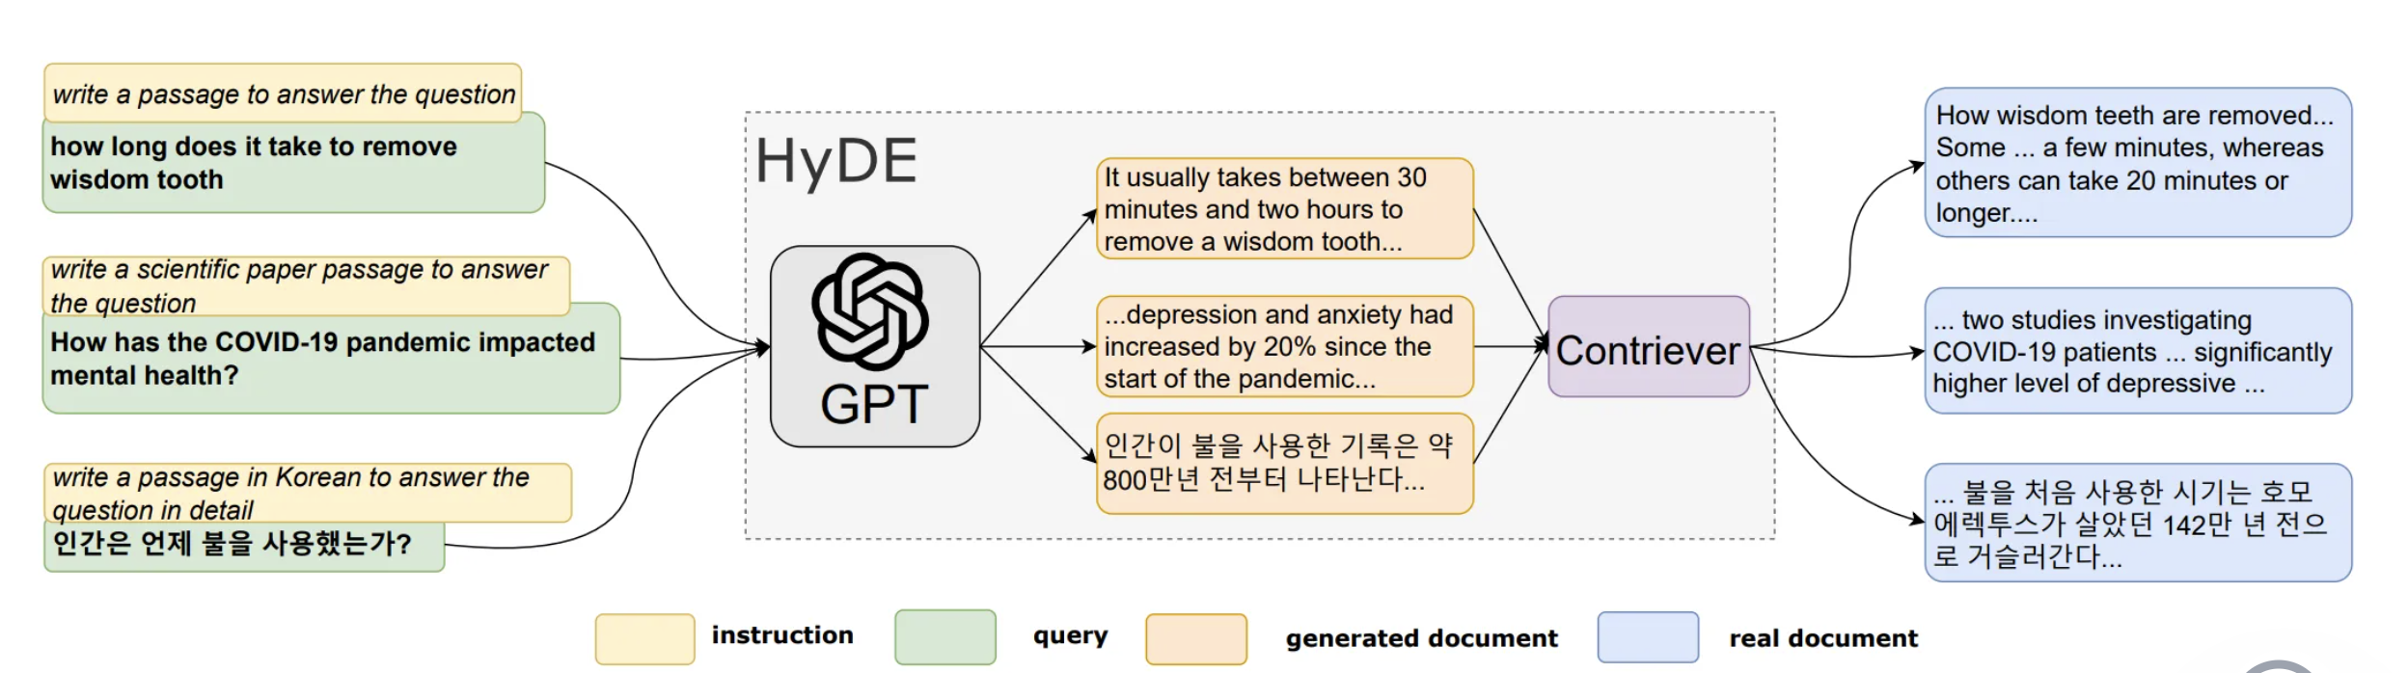

Figure 6.5 HyDE RAG Pattern (sources: https://arxiv.org/pdf/2212.10496.pdf)

You will learn the benefits of this RAG pattern below.

**Enhanced relevance**: The system generates a hypothetical answer. This helps capture the intent of the query better. This often leads to retrieving documents that are more relevant to the user's needs, even if the original query was vague or ambiguous.

**Improved contextual understanding**: Using an LLM helps improve contextual understanding. It generates hypothetical answers. This allows the system to consider a broader context. This is useful for complex queries. Simple retrieval methods may overlook important details.

**Flexibility**: HyDE can adapt to a wide range of queries and content types, making it a versatile approach that can be applied across different domains, from customer support to academic research.

Some of the potential limitations of this RAG pattern are explained below.

**Computational overhead**: Generating a hypothetical answer requires extra computation. This adds to processing time and resource usage. Latency is important for some applications. It can be a concern in those cases.

**Dependency on LLM accuracy**: The effectiveness of the HyDE pattern heavily relies on the quality of the hypothetical answers generated by the LLM. If the model generates incorrect or irrelevant content, it could lead to poor retrieval outcomes.

**Complex implementation**: Integrating an LLM for generating hypothetical answers is complex. It needs a more intricate system design. This may lead to longer development times. Specialized knowledge in natural language processing is also necessary. Additionally, expertise in vector-based retrieval systems is required.

**Multi-query RAG**: Multi-query RAG improves traditional RAG. It expands one user query into several similar queries. Each query retrieves relevant documents from a knowledge base. The retrieved documents are then reranked. The most relevant documents are used to generate the final response. This method enhances the relevance and accuracy of the output. ( <https://arxiv.org/abs/2402.03367>)

Figure 6.6 Multi query RAG Pattern

Reciprocal rank fusion (RRF) is a key algorithm in multi-query RAG patterns. It assigns scores to retrieved documents based on their rank. Then, it reranks the documents accordingly. To calculate the RRF score, use this formula.

**rrfscore = 1 / (rank + k)**

"Rank" indicates the document's current position in a sorted list. This list is based on relevance. "K" is a constant smoothing factor. It modifies the impact of the existing ranks.

When this reranking process is applied within the context of RAG, the technique is known as RAG-Fusion. RAG-Fusion effectively combines the strengths of multiple retrievals, leading to more accurate and contextually appropriate responses. This method is particularly valuable in situations where precision is critical, such as legal document analysis or complex research tasks.

You will learn the benefits of this RAG pattern below.

**Improved relevance**: The system generates multiple queries. It then reranks the results. This process helps capture nuanced information. As a result, it leads to more accurate responses. The responses are also more contextually relevant.

**Higher accuracy**: By using algorithms like RRF, the final response generation process only uses the most pertinent documents, thereby reducing the likelihood of irrelevant or incorrect information.

**Flexibility**: The system can rewrite queries dynamically. This allows it to adapt to different types of questions. It makes the system more versatile across various domains.

Some of the potential limitations of this RAG pattern are explained below.

**Increased complexity**: Expanding a single query into multiple queries and reranking the results adds computational overhead, which can lead to longer response times.

**Dependence on Quality of Expanded Queries**: The technique's effectiveness depends on the quality of generated queries. If the queries are poorly made, they may retrieve irrelevant or redundant information. This can negatively impact the final response.

**Resource-intensive**: Implementing multi-query RAG patterns can be resource-intensive. Algorithms like RAG-Fusion require more processing power. They also need additional storage for handling retrievals and reranking.

**Sentence Window Retrieval RAG:** This RAG pattern focuses on individual sentences for retrieval. This method optimizes information retrieval. The system pulls in relevant information, often just a sentence or two. It avoids using entire documents or paragraphs. This provides the language model (LLM) with targeted data. The generated content is more precise and contextually accurate. Enhanced precision is achieved by retrieving at the sentence level. This reduces noise from larger text blocks. The LLM can focus on the most pertinent details.

Figure 6.7 Sentence window Retrieval RAG Pattern

You will learn the benefits of this RAG pattern below.

**Enhanced Precision**: By retrieving information at the sentence level, this approach reduces the noise often associated with retrieving larger text blocks, allowing the LLM to focus on the most pertinent details.

**Better contextual relevance**: The method incorporates additional context around each retrieved sentence, ensuring that the LLM understands the broader meaning and can generate responses that are more accurate and coherent.

**Efficient retrieval**: Sentence-level retrieval is often more efficient. It works better when relevant information is spread out in a large corpus. This results in quicker retrieval times. It also makes systems more responsive.

Some of the potential limitations of this RAG pattern are explained below.

**Complexity in implementation**: This approach can be more complex to implement, requiring sophisticated algorithms to effectively identify and retrieve the most relevant sentences.

**Risk of missing broader context**: Focusing on sentence-level details improves precision. However, it may cause the loss of important broader context. This context is essential for full understanding.

**Resource intensity**: Depending on the dataset and the complexity of the queries, sentence-level retrieval can be resource-intensive, potentially requiring more computational power and storage.

### **Document Summary Index RAG:** The Document Summary Index RAG pattern is a powerful technique designed to enhance both the speed and accuracy of information retrieval in large-scale systems. Here’s a look at how it works, along with its benefits and limitations.

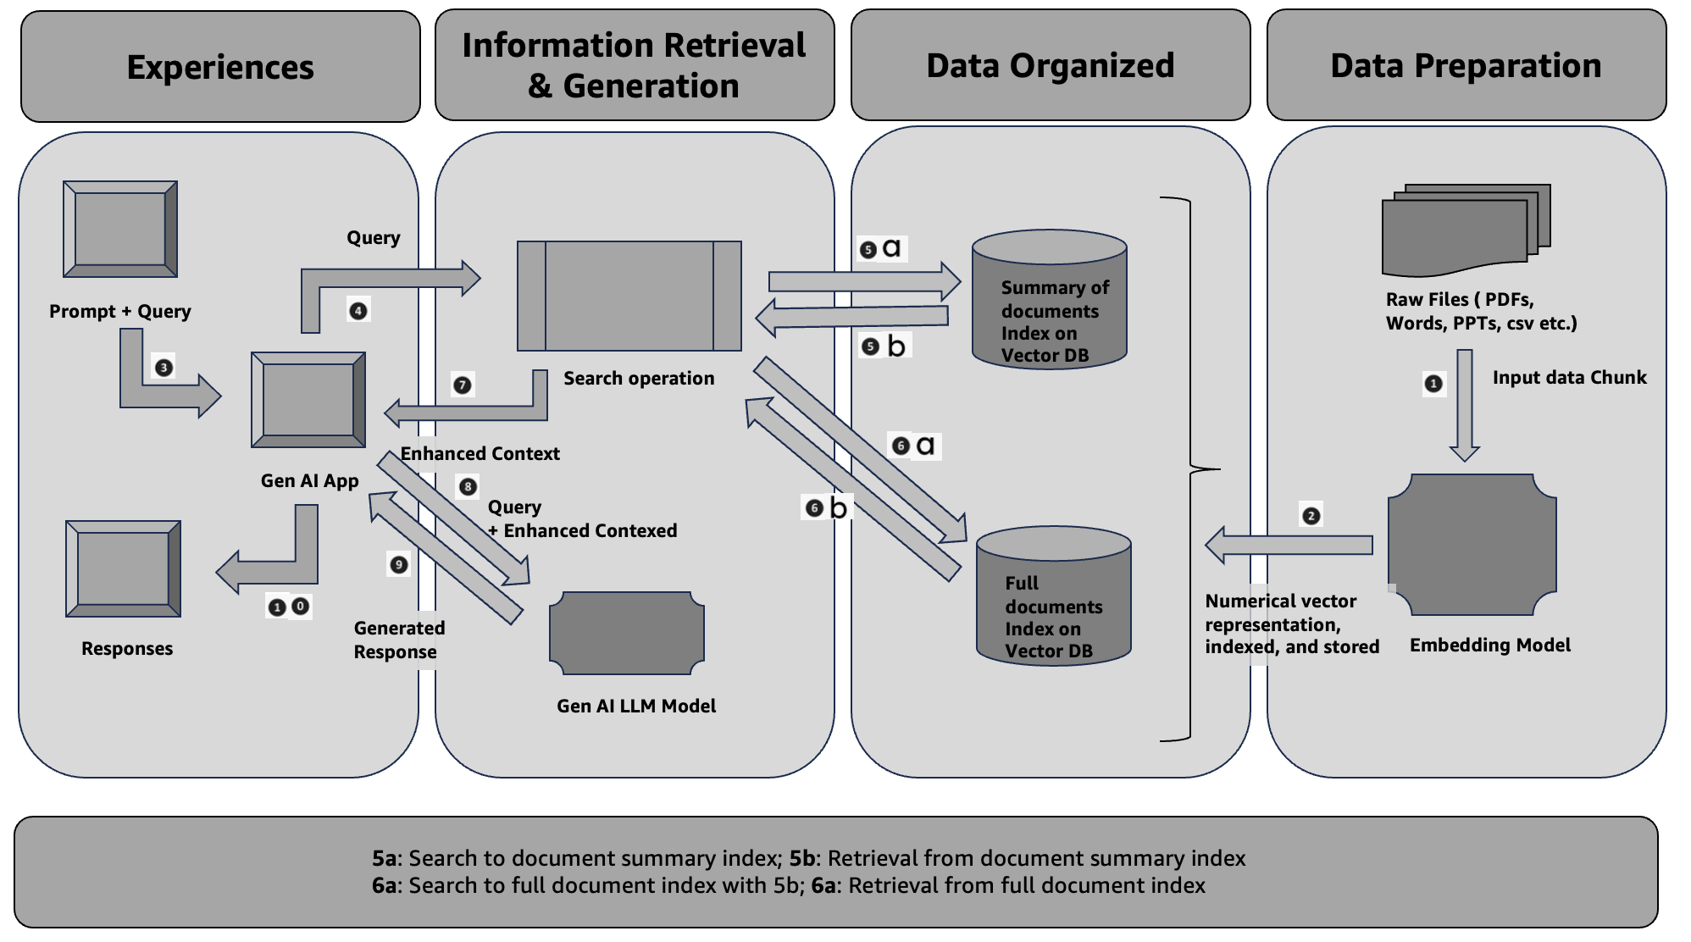

*Figure 6.7 Document Summary Index RAG Pattern*

The Document Summary Index method involves creating an index of document summaries rather than the full documents. When a query is made, the system quickly retrieves relevant summaries from this index. However, for generating responses, the system accesses the full text of the documents. This approach ensures that retrieval is both fast and efficient while allowing the generation of detailed, accurate responses based on the full content. Refer 5a, 5b, 6a, 6b flow on Figure 6.7.

You will learn the benefits of this RAG pattern below.

* **Faster Retrieval Speed: By indexing summaries, the retrieval process is streamlined, as searching through shorter, concise summaries is faster than scanning through entire documents.**

1. **Enhanced Accuracy: Summaries capture the core content of documents, which can lead to more relevant search results. The full documents are still used for response generation, ensuring comprehensive and accurate answers.**
2. **Efficient Storage and Management: Indexing summaries reduces the amount of data that needs to be processed during retrieval, which can lead to more efficient storage and management of information.**

Some of the potential limitations of this RAG pattern are explained below.

**Reliance on summary quality: The effectiveness of this pattern relies heavily on the quality of the summaries. If summaries are not well-crafted or do not capture the essential information, retrieval accuracy can suffer.**

1. **Potential to Miss Context: Summaries might omit nuanced details that are crucial for understanding complex queries. While the full document is accessed for response generation, the initial retrieval might miss relevant context.**
2. **Index Maintenance: Keeping the summary index up-to-date with the latest documents requires additional effort and resources, particularly in dynamic environments where content frequently changes.**

### **Reranker RAG:** Reranker RAG Patterns are a sophisticated approach within Retrieval-Augmented Generation (RAG) pipelines that add an additional layer of refinement to the retrieval process. These patterns involve a reranking step, where documents initially retrieved are reassessed and reordered based on their relevance to the query. This step uses various techniques, such as Maximal Marginal Relevance (MMR), Cohere reranker, or LLM-based rerankers.

**Benefits:**

1. **Enhanced Relevance**: By applying a reranking step, the system improves the relevance of the documents presented in the final output. For instance, MMR helps balance between relevance and diversity, ensuring that the results are both pertinent and varied.
2. **Improved Accuracy**: Rerankers refine the results based on a deeper understanding of the query, leading to more accurate and contextually appropriate responses. This is particularly beneficial in complex queries where initial retrieval might miss nuanced details.
3. **Dynamic Adaptability**: Techniques like LLM-based rerankers can adapt to different types of queries and contexts, making them versatile for various applications. This flexibility ensures that the system remains effective across diverse use cases.
4. **Reduced Noise**: By filtering out less relevant documents in the reranking phase, these patterns help reduce noise and focus on high-quality content, enhancing the overall user experience.

**Limitations:**

1. **Increased Complexity**: Adding a reranking step introduces additional complexity to the RAG pipeline. This can require more computational resources and time, potentially impacting performance, especially in real-time systems.
2. **Potential Overhead**: Implementing sophisticated reranking techniques like LLM-based models might involve significant overhead in terms of both processing power and development effort. This might present a challenge in environments with limited resources.
3. **Dependence on Initial Retrieval Quality**: The effectiveness of the reranking step heavily depends on the quality of the documents retrieved initially. If the initial retrieval process is flawed, reranking may not fully resolve the issues.
4. **Algorithmic Limitations**: Techniques like MMR and Cohere rerankers have their own limitations and might not always align perfectly with the nuances of every query, potentially leading to suboptimal reranking results.

The T-RAG (Tree-Augmented RAG) pattern brings an interesting approach to enhancing retrieval-augmented generation by integrating entity information from knowledge graphs or databases. This method involves merging traditional document retrieval with structured entity data to provide a richer, more comprehensive context for generating responses with large language models (LLMs).

### Benefits of T-RAG Patterns

1. **Better Contextual Understanding**: By incorporating entity information from a knowledge graph, T-RAG provides the LLM with detailed and structured context. This helps in generating more accurate and contextually relevant responses, as the model can leverage both the retrieved documents and the structured entity data.
2. **Improved Answer Quality**: The combination of document retrieval and entity-based augmentation can significantly improve the quality of answers. For example, in a customer support scenario, T-RAG can pull in specific details about products or services from a knowledge graph, allowing the LLM to provide more precise and informative answers.
3. **Better Handling of Ambiguity**: Knowledge graphs help disambiguate queries by providing additional information about entities. This can be particularly useful in complex queries where multiple interpretations are possible. The structured data helps clarify the context, leading to more accurate responses.
4. **Enhanced Flexibility**: The T-RAG approach can be adapted to various domains by customizing the knowledge graph to include domain-specific entities and relationships. This flexibility allows it to be used across different industries and applications.

### Limitations of T-RAG Patterns

1. **Complex Integration**: Merging entity information from a knowledge graph with retrieved documents can be technically challenging. It requires careful integration to ensure that the structured data complements rather than complicates the retrieval process.
2. **Dependence on Knowledge Graph Quality**: The effectiveness of T-RAG is heavily dependent on the quality and completeness of the knowledge graph. Inaccurate or outdated information in the knowledge graph can lead to misleading or incorrect responses.
3. **Increased Computational Overhead**: Integrating knowledge graphs with retrieval systems can introduce additional computational overhead. This may impact the efficiency and speed of the retrieval and generation process, particularly in large-scale applications.
4. **Scalability Concerns**: As the knowledge graph grows, managing and updating it can become increasingly complex. Ensuring that the knowledge graph remains relevant and up-to-date is crucial for maintaining the accuracy and effectiveness of the T-RAG approach.

In summary, T-RAG patterns offer a robust way to enhance the performance of retrieval-augmented generation by combining document retrieval with structured entity information. While they provide significant benefits in terms of context and answer quality, they also come with challenges related to integration complexity, reliance on knowledge graph quality, and scalability.

### LLM-Augmented Retrieval RAG Patterns

The LLM-Augmented Retrieval (RAG) pattern leverages large language models (LLMs) to enhance the retrieval process. Here’s a breakdown of how it works, along with its benefits and limitations.

#### How It Works

In this approach, an LLM is used to generate synthetic titles and relevant queries based on input documents. These synthetic elements are then combined with actual document chunks to create document-level embeddings. These embeddings are stored in a vector database, and user queries are matched against these embeddings to retrieve relevant documents. This method aims to improve the relevance and precision of document retrieval by incorporating both real and synthetic data elements.

#### Benefits

1. **Enhanced Relevance**: By generating synthetic titles and queries, the system can capture additional nuances and contexts that might not be fully represented in the original documents. This leads to more accurate and higher context aware relevancy search results.
2. **Improved Coverage**: Synthetic elements can help cover a broader range of potential queries and topics, increasing the likelihood that user queries will find relevant documents.
3. **Improved Embeddings**: Combining synthetic and real data helps create richer document embeddings, which can improve the performance of retrieval systems by providing more detailed representations of document content.
4. **Scalability**: This pattern can be easily scaled by generating synthetic data for large document collections, making it suitable for systems that need to handle extensive information repositories.

#### Limitations

1. **Quality of Synthetic Data**: The effectiveness of this approach relies heavily on the quality of the synthetic titles and queries generated by the LLM. If the synthetic elements are not well-crafted, they might introduce noise rather than enhancing retrieval performance.
2. **Computational Overhead**: Generating and processing synthetic data requires additional computational resources. This can increase the cost and complexity of maintaining the system, especially at scale.
3. **Contextual Accuracy**: Synthetic elements might not always perfectly align with the actual context or content of the documents, potentially leading to mismatches or irrelevant results in some cases.
4. **Dependency on LLM**: The quality of retrieval is closely tied to the performance of the LLM used for generating synthetic data. If the LLM is not sufficiently advanced or well-tuned, it may not significantly enhance retrieval effectiveness.

In summary, while LLM-Augmented Retrieval RAG patterns offer significant advantages in enhancing relevance and coverage, they also come with challenges related to the quality of synthetic data and computational demands. Balancing these factors is key to leveraging this approach effectively.

### Agentic RAG Workflow Patterns

Agentic RAG workflows represent a sophisticated approach to Retrieval-Augmented Generation (RAG), where agents dynamically interact with various tools to generate responses. These workflows are characterized by their flexibility and adaptability, driven by the agent's ability to select, utilize, and compile results from multiple sources based on the nature of the query. Here’s an overview of how these workflows operate, along with their benefits and limitations.

#### How Agentic RAG Workflows Work

In an Agentic RAG system, the process follows a structured yet dynamic flow:

1. **Query Initiation**: A user query triggers the system.
2. **Tool Selection**: The language model (LLM) evaluates the query and selects the most appropriate tool(s) for retrieving information. These tools might include vector indexes, search APIs, or other specialized databases.
3. **Tool Interaction**: The selected tool(s) receive the query input and perform the retrieval or computation as needed.
4. **Response Integration**: The system collects the responses from the tools.
5. **Dynamic Planning and Iteration**: The LLM processes these responses, planning and looping as necessary to refine and enhance the result.
6. **Final Answer Generation**: The LLM generates and presents the final answer based on the compiled results.

For example, in an information retrieval scenario, the tools might include vector indexes that help find relevant documents, as described in AWS’s documentation on using Agents with Bedrock Knowledge Bases. Depending on the query, the agent might choose different tools and workflows, dynamically adjusting to provide the most accurate and contextually relevant response.

#### Benefits

1. **Flexibility**: The dynamic selection of tools allows the system to adapt to varying query types and complexities. This means it can handle a wide range of questions and data sources effectively.
2. **Improved Accuracy**: By utilizing multiple tools and iterating based on initial results, the system can refine its responses, leading to more accurate and comprehensive answers.
3. **Contextual Adaptation**: The ability to dynamically adjust workflows based on the query ensures that responses are tailored to the specific context and requirements of each query.
4. **Efficient Resources Use**: Different tools have varying strengths. The system’s ability to select the most appropriate tool for each task optimizes resource use and enhances overall efficiency.

#### Limitations

1. **Complexity**: The dynamic nature of these workflows can introduce complexity in terms of system design and maintenance. Managing and integrating multiple tools requires careful orchestration and oversight.
2. **Latency**: The iterative process of tool selection and response integration can introduce latency, potentially impacting response times, especially for complex queries.
3. **Dependency on Tool Quality**: The effectiveness of the workflow is heavily dependent on the quality and relevance of the tools used. If the tools are subpar, the overall performance of the system may be compromised.
4. **Scalability Challenges**: As the number of tools and the complexity of workflows increase, scaling the system to handle a high volume of queries while maintaining performance can become challenging.

In summary, Agentic RAG workflows offer a powerful and flexible approach to generating responses by dynamically leveraging various tools. While they provide significant benefits in terms of adaptability and accuracy, they also come with challenges related to complexity, latency, and scalability. Understanding these dynamics helps in designing more effective and efficient RAG systems.